**Circuitry/Insole Hardware**

The main challenges with designing the insole hardware come from the power requirements of the system. The insole components need to be capable of harvesting enough energy to power a micro controller and bluetooth low energy transmitter. They also need to be capable of handling the pressure applied by a footstep, and creating a measurable voltage to be used as footstep detection.

**Requirements**

Flexible and robust insole material

Transducers capable of producing energy and a measurable voltage

Energy storage component

**Solutions**

The insole material will be made from a flexible silicon rubber. This allows for a resizable design so that the insole can be kept thin, while maximizing potential energy generation.

The transducers will be made from a piezoelectric material. This allows for the production of energy, a measurable voltage, and the material options allow for thin and flexible material choices.

The energy storage component would be ideally a low leakage capacitor. Due to the low energy nature of the system, the leakage from electrolytic capacitor has been found to be a significant portion of the total energy consumption. A super capacitor has low energy loss but would require a long time to charge. A battery is the last resort option since they are generally poor choices for constant charge, discharge applications and more sensitive to temperature and pressure than other options.

**Design Drawings**

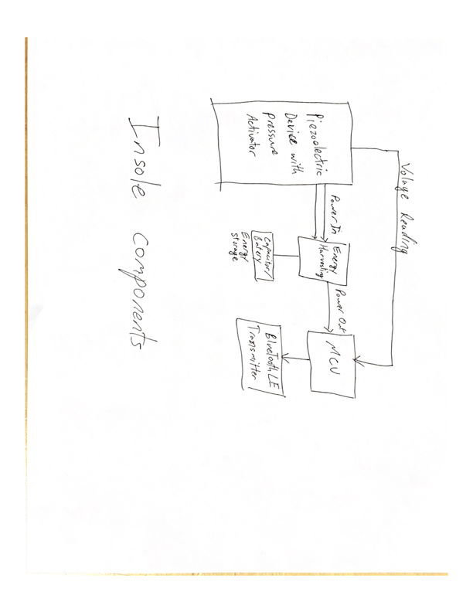

This is the general block diagram of the insole system. The transducers will be measured to determine pressure as well as used to harvest energy. That energy will be stored and used to power a micro controller that will read the voltage on the transducer(s) then send those reading over a Bluetooth LE connection.

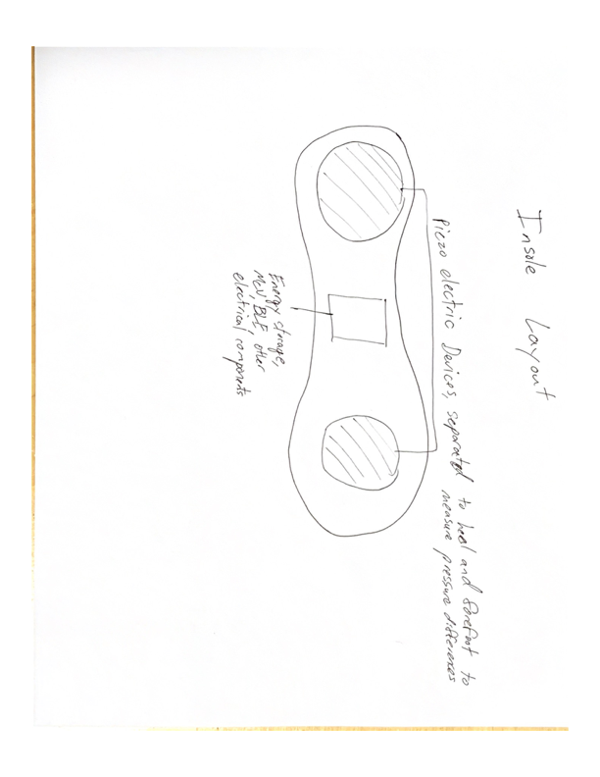

This will be the layout of the insole. The transducers will be separated into different locations on the foot. This lets the data to be position dependent, meaning relative pressure in different areas can be determined.

The piezoelectric device needs a flexible voltage generating film. PVDF material is a perfect choice for this. The material needs to be deformed to produce the voltage as well, this is why the activator is required. Due to the semi-rigidity but flexibility silicon rubber provides, it is currently the top choice.

The voltage generated by the piezo devices will alternate, thus we will use full bridge rectifiers to polarize the voltage so it can be stored on a capacitor. The uncontrollable nature of the voltage requires that a buck 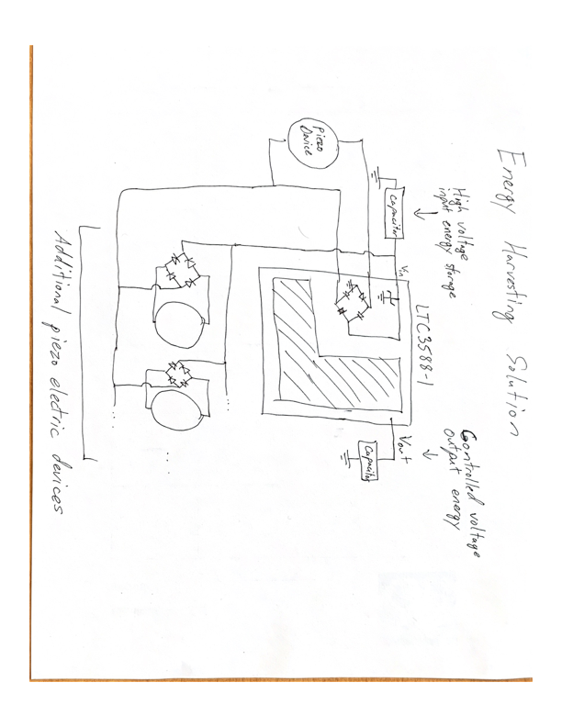regulator or similar type of voltage controller be used so that a voltage level adequate to power a microcontroller can be output. This amounts to the picture shown to the left. The LTC3588 has voltage output controlling components, and high voltage energy can be stored on the input capacitor to be used to power the output capacitor at a controlled voltage. This system requires two capacitors and a full bridge rectifier circuit for every additional piezo device we use, giving us to option to scale the system to meet requirements.

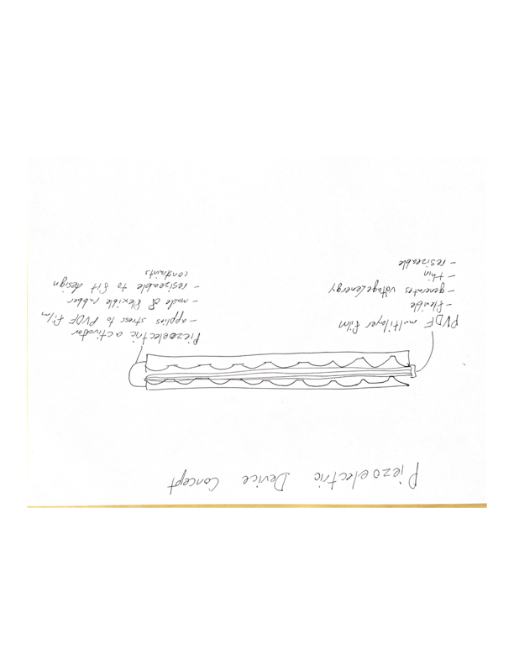

**Piezo material / sensors**

The piezo electric material needs to be capable of producing voltages greater than the voltage being used to power the system. Piezo materials that come in films can be layered to produce more voltage. PVDF seems to be the only good choice for this. It comes in layers so it’s scalable, it’s bendable and not heat sensitive, and it’s relatively cheap depending on where you get it from.

Possible Options:

The options here are scarce for those unwilling to spend hundreds of dollars, and overwhelming for those willing.

Generic ceramic PiezoBuzzer (1-3$ each)

- These are a great option for prototyping due to their cost and operating characteristics

- If a way could be developed to make these more robust, they are a great power option

as well due to the large capacitance

Specific ceramic buzzer

(2.5$ each) - <https://www.digikey.com/product-detail/en/APS4812B-LW100-R/668-1190-ND/1738483>

- Thick but extremely larger capacitance to justify it

(2.3$ each) - <https://www.digikey.com/product-detail/en/AB4113B-LW100-R/668-1409-ND/4147333>

- Thin and wide area may help with stress

20AWG Cable-Copolymer ($35/meter) - https://www.digikey.com/product-detail/en/te-connectivity-measurement-specialties/1005801-1/223-1223-ND/4862192

- This cable option is a possibility but the thinnest it can get is around 2.6mm

- This seems to be one of the better options price vs quality wise as well

High quality sheet (8’’x11’’) - $133

https://www.digikey.com/product-detail/en/te-connectivity-measurement-specialties/1-1004347-0/223-1320-ND/5277280

- This is pretty much exactly what we’re looking for, but it’s very expensive, especially for the amount of material we get.

- It does seem like enough material to experiment with however, and since it’s in sheet form, could be very malleable

**Piezo Activator Material**

The piezo activator needs to be thin enough to fit comfortably in a shoe while being flexible enough to withstand a fair amount stress. The best type of material for this seems to be overwhelmingly rubber of some sort. It’s flexible, incredible robust, cheap, can be made thin, and there’s many options.

Possible options:

Silicone Rubber (24-100$) - <http://siliconesolutions.com/ss-8112.html?_vsrefdom=adwords&gclid=Cj0KCQjw0dHdBRDEARIsAHjZYYB4GZ9MGousYpa0Q5rTiDGB3IViZbp3X2PF8dFdV0rzuUL9G7smgIMaAhqfEALw_wcB> is a 24$ version

- Silicone rubber can be cast then cured to take on any shape

Flexible 3D printing filament:

(40$) <https://www.amazon.com/eSUN-eLastic-Flexible-Printer-Filament/dp/B01A4WP4AY/ref=sr_1_1_sspa?ie=UTF8&qid=1538631121&sr=8-1-spons&keywords=esun+elastic&psc=1>  
 - most flexible, therefore also weakest

(38$) https://www.matterhackers.com/store/l/taulman-black-pctpe-filament-175mm/sk/MF1SV5MP?rcode=GAT9HR&gclid=Cj0KCQjw0dHdBRDEARIsAHjZYYDA6VmY7QY3KDw9Un3oK_78S63tapgvDIWmhVeBvXaZuuQeOh6J078aAq30EALw_wcB

- less flexible, stronger

**Diodes / Full wave rectifier circuit**

Since we wish to harvest the most energy possible, low forward voltage diodes are desired so as to lose the least amount of power during rectificatio. Also due to the potentially high voltage output of the piezoelectric components, the diodes will need to have sufficiently high reverse voltage ratings. The LTC3588-1 chip has a built in shunt regulator to protect against voltages greater than 20V, so since 20V is potentially our maximum, anything greater than 20V should be a sufficient reverse breakdown voltage.

* The LTC3588-1 has a low power loss rectifier already on board

Possible Options:

BAT41 - $0.50

<https://www.vishay.com/docs/85659/bat41.pdf>

1N5711 - $0.39

<http://www.learnabout-electronics.org/Downloads/1N5711.pdf>

1N5818 - $0.48

https://www.diodes.com/assets/Datasheets/ds23001.pdf

**Capacitor**

The sizing of the capacitors depends on multiple things: general power requirements of system operation, peak power requirements, and efficiency of energy harvesting. The system will consume a constant amount of energy during operation and peak in energy consumption during the during the Advertising phase of the BLE operation.

* The constant energy consumption is best solved by a larger output capacitor so that the Buck Converter inside the LTC3588-1 can remain off most of the time, increasing power efficiency of the input to output capacitor energy transfer.
* The peak power consumption will best be solved by a larger input capacitor since the energy consumption of the system during that time will likely be too large for the output capacitor to sustain without a significant drop in voltage.
* The efficiency of the energy harvest will depend on the capacitor leakage current as well. If there’s a significant amount of leakage, the system will be significantly less efficient. Thus the capacitors should have as low leakage currents as possible.

The LTC3588-1 provides the following equation

E_peak is in the range of 20-40uJ, varies based on voltage and transmission power. Before BLE operations the micro controller may need to check the voltage on V_in to determine if theres enough power to transmit properly and confidently.

Possible Options:

KR super capacitors

+ low leakage

- thick (4.7mm minimum)

- large capacitance (100mF minimum)

DMHA14R5V353M4ATA0

+Thin (0.4mm)

- Somewhat high leakage current (up to 60uA)

+ smaller than most super capacitor capacitance (35mF)

DMF3Z5R5H474M3DTA0

+ Low leakage(5uA)

- thick (3.2mm)

- large capacitance (470mF)

Aluminum Electrolytic Capacitors

+ Many sizing options

+ Small

+ Higher efficiency

It seems the best option is traditional aluminum electrolytic capacitors. They come in many sizes and dimensions, and have a greater efficiency than more super capacitors. The efficiency of the different options should still be explored for our specific system requirements as it may cause difference from the data sheets.

**Alternative Options**

In the case that energy cannot be harvested at the desired rate or the activator system is too thick for comfort, the energy harvesting system can be replaced with a battery or super capacitor, and the force sensing aspect can be replaced with resistive force sensors.

Battery:

Pros

- Max energy density, can provide power for entire lifetime of device

Cons

- Potentially dangerous, batteries are volatile components, especially when exposed to significant heat/stress, which is what would happen in a shoe

Super Capacitor

Pros

- Extremely fast charging, in the range of seconds

- Far safer than batteries, extremely robust

Cons

- Less energy storage means charging (user maintenance), it would however be able to store enough power for weeks-months of the device

Resistive Sensors

Pros

- More accurate force sensing

- Better, cheaper options

Cons

- More energy consumption, meaning the energy harvesting technique is almost definitely not possible so this would be a side effect of the battery alternative